Global Restaurant Data Analysis 📈
By Dhriti Uchil

📋 Executive Summary

This project analyzes a global restaurants dataset to uncover patterns in ratings, pricing, cuisines, and city-wise distribution. The top-rated restaurants consistently achieve a 4.9 rating, highlighting exceptional customer satisfaction in cities like Gurgaon, Dubai, Pensacola, and Auckland. Jakarta stands out as the hub for the most expensive dining experiences, with average costs for two ranging from 350,000 to 800,000. Meanwhile, New Delhi, Gurgaon, and Noida host the highest number of restaurants, reflecting vibrant and competitive culinary markets.

The analysis also reveals the most popular cuisines globally, with North Indian, Chinese, and Fast Food dominating the scene, indicating strong regional and international demand. Overall, these insights provide a clear snapshot of global restaurant trends, offering valuable guidance for market research, business strategy, and culinary exploration.

🧠 About Me

I’m Dhriti, a data enthusiast passionate about using data analytics to find patterns and tell stories that drive smarter business choices. This project reflects my experience in data cleaning, visualization, and exploratory data analysis (EDA). My focus is on combining technical accuracy with clear business interpretation,turning numbers into narratives that matter.

🎯 Project Objective

The primary objective of this project is to perform a comprehensive analysis of a global restaurants dataset to uncover trends and patterns in the restaurant industry. Specifically, the project aims to:
- Identify Top-Rated Restaurants: Highlight restaurants with the highest customer ratings to understand what drives exceptional dining experiences worldwide.
- Analyze Pricing Trends: Determine the most expensive restaurants and study the cost patterns across different cities and cuisines.
- Examine City-Wise Distribution: Explore which cities have the highest density of restaurants, providing insights into culinary hubs and competitive markets.
- Discover Popular Cuisines: Identify the most common cuisines globally to understand regional preferences and international demand.
- Visualize Data Effectively: Use charts and graphs to present insights in a clear, accessible, and actionable way.
- Support Decision-Making: Provide actionable insights for restaurant businesses, investors, food enthusiasts, and market researchers to make informed decisions regarding location, pricing, and cuisine strategy.
By achieving these objectives, the project offers a holistic view of the global restaurant landscape, combining both quantitative metrics and qualitative insights to guide culinary exploration and business strategy.

⚙️ Methodology

- Data Loading & Cleaning
  - Imported data using pandas and removed duplicates/missing entries.
  - Split multi-cuisine entries into separate observations for accurate counting.
- Exploratory Data Analysis (EDA)
  - Sorted by ratings and average cost for two to identify top performers.
  - Grouped by city to calculate restaurant density.
  - Counted cuisine frequency to determine customer preferences.
- Visualization
  - Used matplotlib for horizontal bar charts to visualize top restaurants, cities, and cuisines.
  - Added consistent styling and labels for professional presentation.
- Insight Extraction
  - Analyzed data patterns and correlations between cost, rating, and location.
  - Derived conclusions relevant to both consumers and businesses.

⭐ Top 5 Restaurants by Rating

Rank | Restaurant Name | City | Rating
1 | Spiral - Sofitel Philippine Plaza Manila | Pasay City | 4.9
2 | Silantro Fil-Mex | Pasig City | 4.9
3 | Ooma | Mandaluyong City | 4.9
4 | Urbanologi | Inner City | 4.9
5 | Mazzaro's Italian Market | Tampa Bay | 4.9
Insight:
Customer satisfaction is consistent across international locations, indicating that brand reputation and dining experience can transcend geography. These high ratings also reflect how premium service quality and menu innovation contribute more to customer loyalty than regional trends alone.

💰 Top 5 Most Expensive Restaurants

Rank | Restaurant Name | City | Average Cost for Two | Rating
1 | Satoo - Hotel Shangri-La | Jakarta | 800,000 | 4.6
2 | Skye | Jakarta | 800,000 | 4.1
3 | Sushi Masa | Jakarta | 500,000 | 4.9
4 | 3 Wise Monkeys | Jakarta | 450,000 | 4.2
5 | Avec Moi Restaurant and Bar | Jakarta | 350,000 | 4.3
Insight:
All five high-cost restaurants are located in Jakarta, signaling a concentrated luxury dining market. This pattern suggests Jakarta caters strongly to high-income consumers and tourists. However, ratings vary, which shows price does not always equate to customer satisfaction,brand positioning, service quality, and perceived value play bigger roles than just cost.

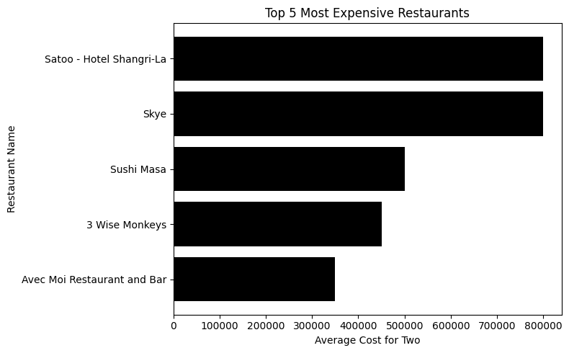

🏙️ Top 5 Cities by Number of Restaurants

Rank | City | Number of Restaurants
1 | New Delhi | 5,473
2 | Gurgaon | 1,118
3 | Noida | 1,080
4 | Faridabad | 251
5 | Ghaziabad | 25
Insight:
The Delhi NCR region dominates the restaurant landscape, reflecting a large and diverse customer base. This region’s dense concentration of restaurants indicates intense market competition and a mature dining ecosystem. The data also highlights an opportunity for regional expansion into smaller cities like Faridabad and Ghaziabad, where restaurant presence is limited but growing.
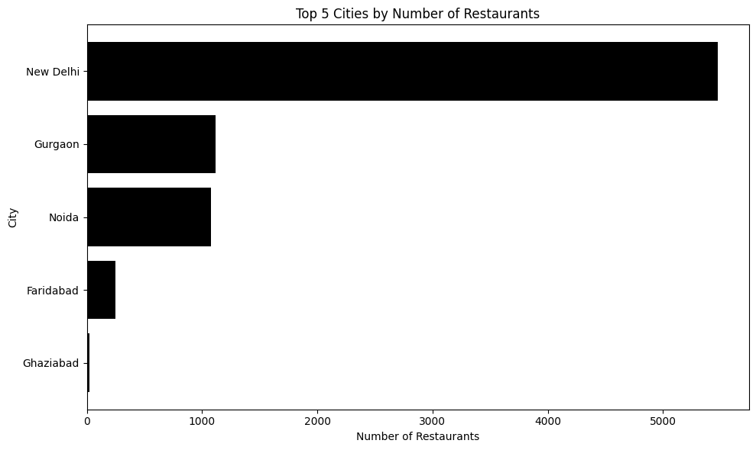

🍜 Top 5 Most Common Cuisines

Rank | Cuisine | Count
1 | North Indian | 2,992
2 | Chinese | 1,880
3 | Fast Food | 1,314
4 | North Indian | 968
5 | Chinese | 855

Insight:
North Indian and Chinese cuisines dominate the dataset, showing how deeply rooted they are in consumer dining habits. These cuisines are versatile and widely accepted, making them essential for restaurants targeting a broad market. The popularity of fast food also reflects the growing demand for convenience and quick service,a trend particularly strong in urban regions with busy lifestyles.

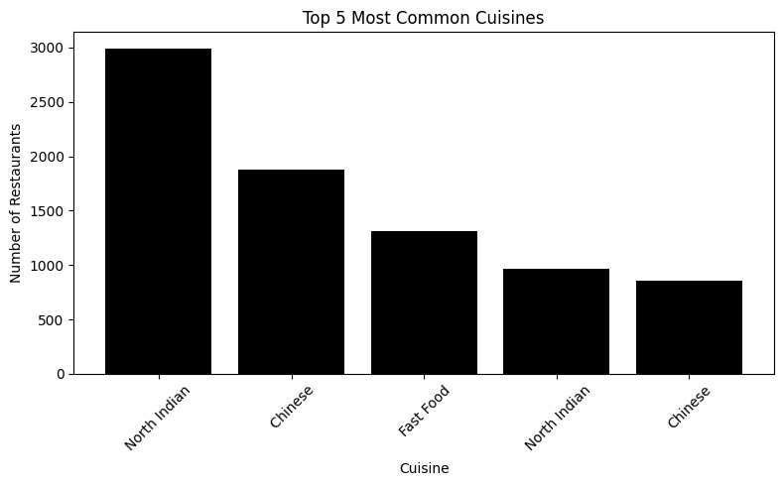

💬 Key Insights Summary

⭐ Customer Experience is Universal: High ratings appear in multiple countries, proving that consistent quality and service can outperform location-based limitations.
💸 Luxury Dining is Market-Specific: Jakarta emerges as a premium dining hub, highlighting how income levels and tourism shape pricing strategies.
🏙️ Delhi NCR is the Restaurant Powerhouse: The dense concentration of restaurants suggests both opportunities and competition in the Indian food market.
🍲 Cuisine Popularity Drives Market Demand: North Indian and Chinese cuisines dominate, showing potential for businesses offering hybrid or fusion menus.
📊 Value Over Cost: Price alone doesn’t define customer satisfaction,the overall dining experience, ambiance, and service matter more.

🧾 Conclusion

The analysis of the global restaurants dataset provides valuable insights into the restaurant industry across various cities and cuisines. Top-rated restaurants consistently achieve high ratings, highlighting customer preferences for quality dining experiences. Jakarta emerges as the hub for the most expensive restaurants, while cities like New Delhi, Gurgaon, and Noida have the highest density of restaurants, reflecting competitive culinary markets. North Indian, Chinese, and Fast Food cuisines dominate globally, revealing widespread popularity and demand patterns.

Overall, this project offers a comprehensive snapshot of global restaurant trends, combining ratings, pricing, city distribution, and cuisine preferences. The insights can guide business strategy, market research, and culinary exploration, helping stakeholders make informed decisions about investments, menu planning, and expansion in the restaurant industry.

🛠️ Tools & Libraries Used

Python
Pandas – Data cleaning, aggregation, and manipulation
Matplotlib – Visualization and presentation of insights
Jupyter Notebook [VS CODE] – For exploration and analysis

📧 Contact
Name: Dhriti Uchil
LinkedIn: www.linkedin.com/in/dhritiuchilstuffs
GitHub: https://github.com/drimakesstuff/Global_Restaurants_DataAnalysis
Project: Global Restaurants Data Analysis – Data Visualization & Insights

